Practical No: 7
Name:- Danish Altaf Solkar Enrolment No:- 24111590805
Class:- CO3KB Subject:- CGR
Aim :- WAP for 2D Translation
Program :-
#include<stdio.h>
#include<conio.h>
#include<graphics.h>
void main(){
int gd=DETECT,gm;
int x1,y1,x2,y2;
int tx,ty;
clrscr();
printf("\nEnter the x,y co ordinates of line endpoints :- ");
scanf("%d%d%d%d",&x1,&x2,&y1,&y2);
initgraph(&gd,&gm,"C:\\TurboC3\\BGI");
printf("\nOriginal before Translation :- ");
line(x1,y1,x2,y2);
printf("\nEnter the Translation factor :- ");
scanf("%d%d",&tx,&ty);
x1=x1+tx;
y1=y1+ty;
x2=x2+tx;
y2=y2+ty;
printf("\nLine after Translation :- ");
setcolor(12);
line(x1,y1,x2,y2);
getch();
closegraph();
}
OUTPUT :-
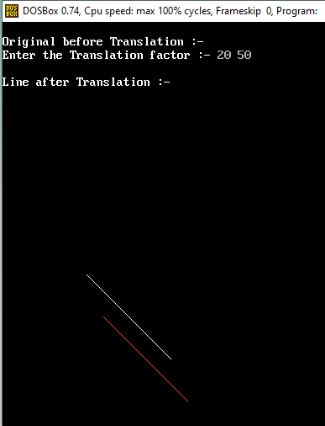
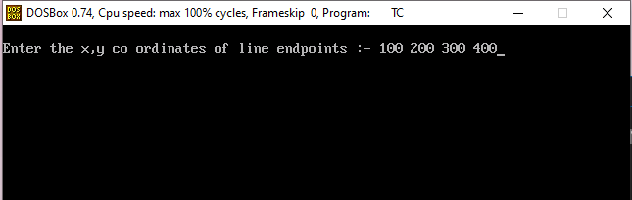

Aim :- WAP for 2D Scaling
Program :-
#include<stdio.h>
#include<conio.h>
#include<graphics.h>
void main(){
int gd=DETECT,gm;
int x1,x2,y1,y2;
int Sx,Sy;
clrscr();
printf("\nEnter the co ordinates :- ");
scanf("%d%d%d%d",&x1,&y1,&x2,&y2);
initgraph(&gd,&gm,"C:\\TurboC3\\BGI");
printf("\nOriginal Before Scaling :- ");
rectangle(x1,y1,x2,y2);
printf("\nEnter the Scaling factor :- ");
scanf("%d%d",&Sx,&Sy);
x1=x1*Sx;
y1=y1*Sy;
x2=x2*Sx;
y2=y2*Sy;
printf("\nAfter scaling :- ");
setcolor(10);
rectangle(x1,y1,x2,y2);
getch();
closegraph();
}
OUTPUT :-
